Demonstration of Proposed Features
Field | Details
Date | 01 October 2026
Team ID | SWTID-2026-3718
Project Name | ComicCraft - AI Comic Story Creator
Maximum Marks | 1 Mark

Demonstration of Proposed Features
S.No | Feature Name | Description | Status | Demonstrated | Remarks
1 | Story input | Accepts story prompt plus character, setting, tone and art style. | Implemented | Yes | Source-supported; live AI output depends on configuration.
2 | Five-panel outline | Gemini planning creates exactly five connected panels. | Implemented | Yes | Source-supported; live AI output depends on configuration.
3 | Narration and dialogue | Story expansion adds caption, narration and dialogue. | Implemented | Yes | Source-supported; live AI output depends on configuration.
4 | AI panel artwork | Generates one image per panel with fallbacks. | Implemented | Yes | Source-supported; live AI output depends on configuration.
5 | Comic preview | Displays five panels and story text. | Implemented | Yes | Source-supported; live AI output depends on configuration.
6 | Inline image embedding | Embeds JPEGs as base64 with static fallback. | Implemented | Yes | Source-supported; live AI output depends on configuration.
7 | PDF export | Creates five-page A4 PDF. | Implemented | Yes | Source-supported; live AI output depends on configuration.
8 | Safe PDF download | Validates generated PDF filename. | Implemented | Yes | Source-supported; live AI output depends on configuration.
9 | Demo mode | Runs workflow without external AI calls. | Implemented | Yes | Source-supported; live AI output depends on configuration.
10 | Health/diagnostics | Provides /health and /test-image. | Implemented | Yes | Source-supported; live AI output depends on configuration.
11 | Warnings and fallbacks | Reports failures and uses backup paths/placeholders. | Implemented | Yes | Source-supported; live AI output depends on configuration.
12 | JSON generation API | Exposes /generate-comic/json. | Implemented | Yes | Source-supported; live AI output depends on configuration.

Feature Implementation Summary
Metric | Value
Total Features Proposed | 12 documented capabilities
Total Features Implemented | 12
Total Features Demonstrated | 12 in the project workflow/design; live provider behavior depends on configuration
Overall Implementation Rate (%) | 100% of documented capabilities are implemented in source; this is an implementation count, not a performance score.

Demonstration Evidence
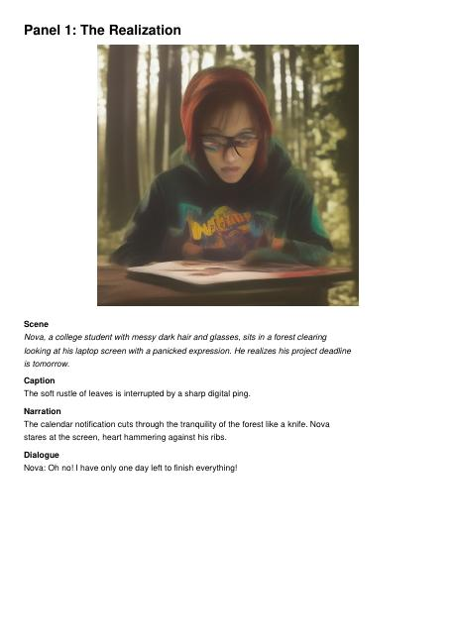
Actual ComicCraft generated output from the supplied project ZIP.

